High Level Design Of Online Food Delivery System Zomato

1. **User Interface:**
   * **Customer App:** Provides features for browsing restaurants, placing orders, tracking orders, and making payments.
   * **Restaurant App:** Allows restaurant owners to manage their menus, receive orders, and update order statuses.
   * **Delivery Agent App:** Enables delivery agents to view assigned orders, navigate to delivery locations, and mark orders as delivered.
2. **Backend Services:**
   * **User Management:** Handles user registration, authentication, and profile management.
   * **Restaurant Management:** Manages restaurant data, menus, and order processing.
   * **Order Management:** Handles order placement, tracking, and delivery assignment.
   * **Payment Gateway Integration:** Facilitates secure payment transactions between customers, restaurants, and delivery agents.
3. **Database Schema:**
   * **User Database:** Stores user profiles, authentication credentials, and order history.
   * **Restaurant Database:** Stores restaurant details, menus, and order information.
   * **Order Database:** Tracks order status, delivery details, and payment information.
   * **Location Database:** Stores geographic data for restaurants and delivery zones.
4. **Third-Party Integrations:**
   * **Maps API:** Integrates with mapping services for location-based services, including restaurant search and order tracking.
   * **Payment Gateways:** Integrates with payment processing services for secure and seamless transactions.
   * **Push Notification Services:** Enables real-time order updates and notifications for customers, restaurants, and delivery agents.
5. **System Architecture:**
   * **Microservices Architecture:** Utilizes a distributed architecture with modular services for scalability and flexibility.
   * **RESTful APIs:** Provides a set of REST APIs for communication between frontend applications and backend services.
   * **Load Balancing and Caching:** Implements load balancers and caching mechanisms to optimize performance and ensure high availability.
6. **Security Measures:**
   * **Data Encryption:** Encrypts sensitive data such as user credentials and payment information to ensure confidentiality.
   * **Access Control:** Implements role-based access control (RBAC) to restrict access to authorized users only.
   * **Secure Communication:** Utilizes HTTPS protocol for secure communication between client applications and server endpoints.
7. **Scalability and Performance:**
   * **Horizontal Scaling:** Designs the system to scale horizontally by adding more instances of services to handle increased load.
   * **Caching Mechanisms:** Implements caching strategies to reduce database load and improve response times.
   * **Asynchronous Processing:** Utilizes message queues and background processing for tasks such as order processing and notifications.
8. **Monitoring and Logging:**
   * **Logging Framework:** Implements a centralized logging system to capture application logs for monitoring and troubleshooting.
   * **Metrics and Monitoring Tools:** Utilizes monitoring tools to track system performance, resource utilization, and error rates in real-time.

This high-level design provides an overview of the key components and architectural considerations for building a food delivery system Zomato. It outlines the system's user interfaces, backend services, database schema, integrations, architecture, security measures, scalability strategies, and monitoring/logging approaches.

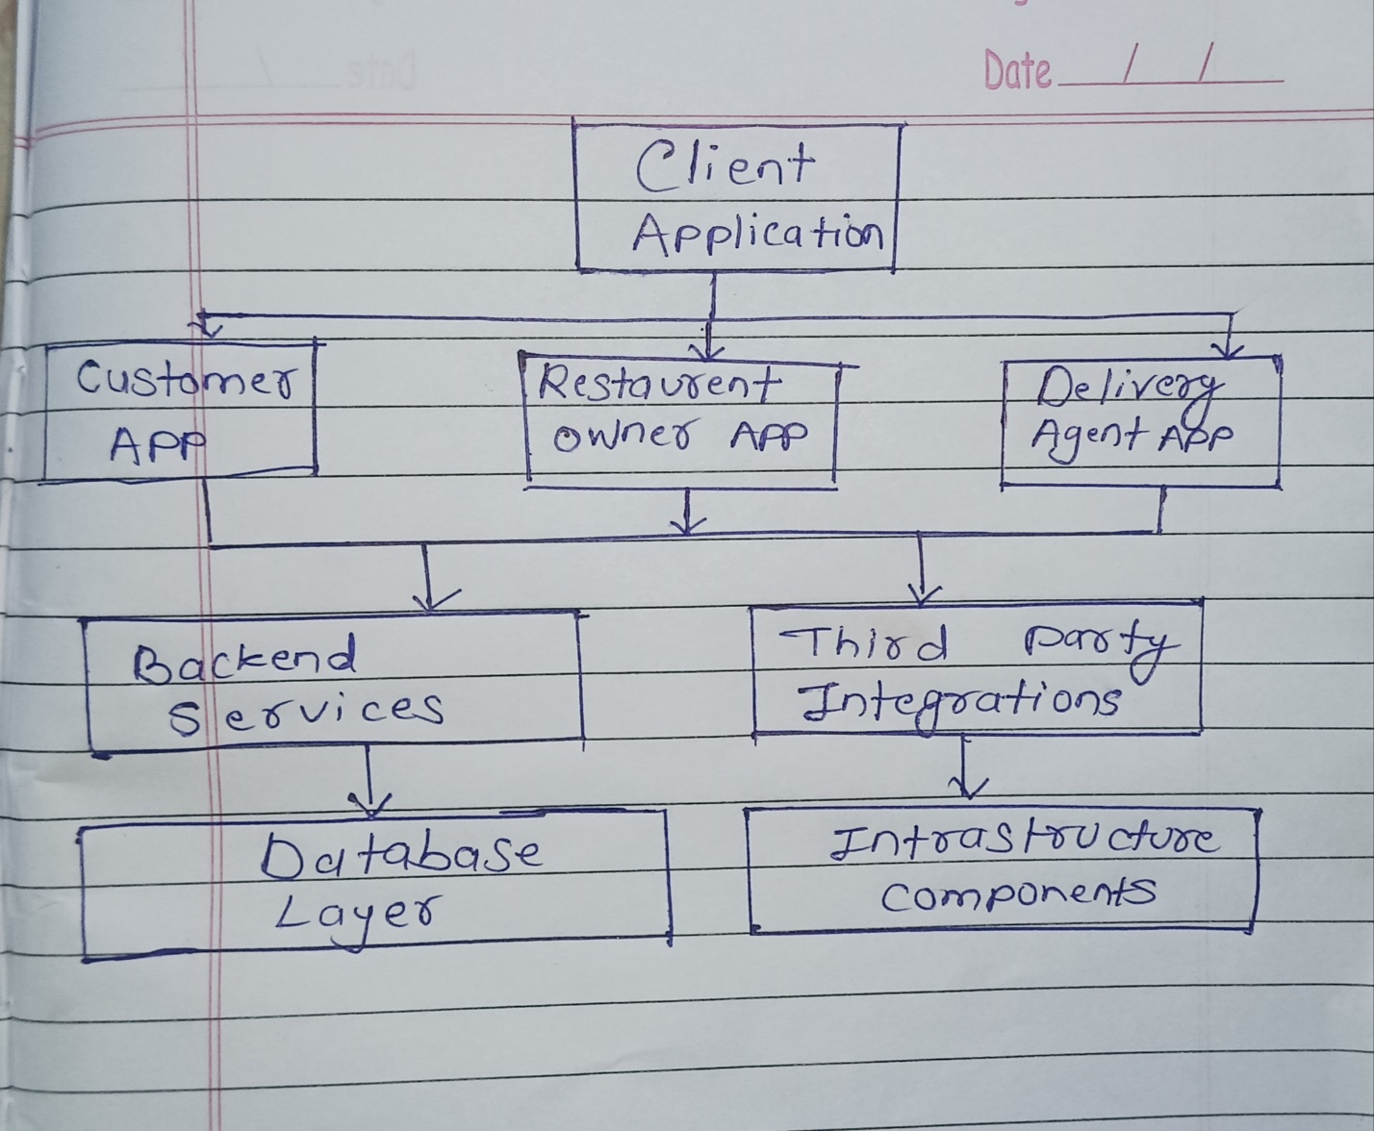

Explanation:

* **Client Applications:** Interfaces accessible to end-users for interacting with the system.
  + **Customer App:** Allows customers to browse restaurants, place orders, and track deliveries.
  + **Restaurant Owner App:** Enables restaurant owners to manage menus, receive orders, and update order statuses.
  + **Delivery Agent App:** Used by delivery agents to view assigned orders, navigate to delivery locations, and update delivery statuses.
* **Backend Services:** Responsible for core business logic and data processing.
  + Consists of services like User Management, Restaurant Service, Order Management, Payment Service, and Notification Service.
* **Database Layer:** Stores and manages persistent data used by the system.
  + Includes databases for users, restaurants, orders, and locations.
* **Third-Party Integrations:** External services integrated into the system for additional functionality.
  + Examples include Maps API for location services, Payment Gateway for payment processing, and Push Notification Service for real-time updates.
* **Infrastructure Components:** Foundational elements supporting the system's operation.
  + Includes Load Balancer for traffic distribution, Cache for performance optimization, Message Queue for asynchronous processing, and Monitoring and Logging for system health and troubleshooting.

This block diagram provides a high-level overview of the system architecture, illustrating the interaction between various components and their roles within the food delivery system.